

**INDIAN INSTITUTE OF INFORMATION TECHNOLOGY, NAGPUR**

C/o Regional Telecom Training Centre (RTTC) BSNL, Seminary Hills, Nagpur-440006 091-0712-2801369, Email: registrar@iiitn.ac.in

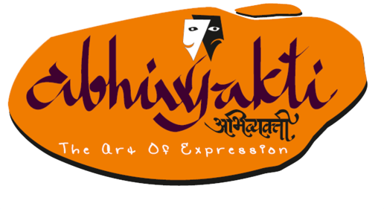---------------------------------------------------------------------------------------------------------------------------------------------------

Presents Pathanatya

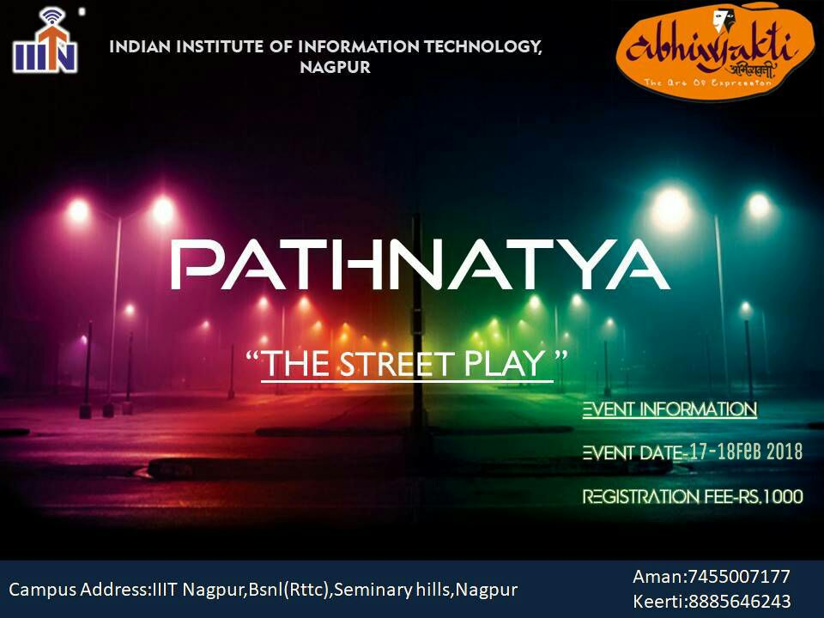

**About the Event:**

Pathanatya, is a street play contest of, the annual cultural fest of IIIT Nagpur, Abhivyakti. Street Play is perhaps the best way to connect with the common man and the youth. These are much intimate, brief, direct and address the social/political message head-on with the help of drama. The catchy phrases and songs, crisp script, humour and loudness help in making a long lasting and powerful effect on viewers.

**Props:**

* Any props or other production material has to be brought by the teams themselves, but the organizers hold the direction of allowing it on stage.
* The authority is not responsible for damage or theft of your props.

**GENERAL RULES:**

* Participants must possess a valid proof of successful registration for the event. (Can register by visiting www.website.com)
* Participants must possess a valid college identity card of their institution. And only registered people are allowed to take part in the event.
* Performance should be in Hindi or English or both. No other languages will be allowed.
* Pre-recorded music is allowed and should be brought in a pen drive in .mp3 format only. (Other FORMATs may be brought and used at your own risk.) and Live Music is also allowed
* Any kind of fluid, live animals, flame, heavy object or any material which has possibility of damaging the area is not allowed.
* Obscenity at the discretion of the judges of any kind is not allowed and will lead to immediate disqualification.
* Inappropriate content, blasphemy or content defaming any political or religious group is strictly prohibited.
* Time limit of maximum 30 minutes should be strictly followed. Participants will be penalized by judges for not doing so.
* The decision of the judges will be final and binding.
* You need to get ready along with your performance at least 10 minutes before the event starts.
* Every participant(s) are required to fill up the “undertaking”.
* **Please, do collect your identity cards available at the registration desk.**

**Note:**

**Stage Specifications:**

* Open ground with no electrical assistance.
* Amplifiers will be provided.

**Note**: In case of any discrepancy decision of Team Abhivyakti will be final.

**REGISTRATION FEES:** 1000/- per team

**Prizes:**

**1st Winner : INR 5000\***

**2nd Winner : INR 3000\***

**Contact Us:**

Keerti Bajaj : 8885646243

Aman Soni : 7455007177